
Student full name
Nicolas Anibal Pizarro Puebla
Student Number
2026491
Module Title
Strategic thinking
Assessment Title
CA 1 – Capstone Project Proposal
Lecture / Supervisor
Taufique Ahmed
Assessment Due Date
25-10-2026
Date Of Submission
24-10-26

Contenido
Predictive Analytics of Pedestrian Footfall to Support Retail and Hospitality Business Planning in Dublin City Centre 3
2. Introduction 3
4. Aim 3
5. Scope 3
6. Methodology 4
7. Data Sources 5
9. Project Timeline 6
10. Ethical and Legal Considerations 6
Use of AI Tools 7
Delegation 7
Discernment 8
Diligence 8
Appendix: AI prompts and outputs 9
A1 9
A2 10
A3 11
A4 12
A5 14
A6 15

Predictive Analytics of Pedestrian Footfall to Support Retail and Hospitality Business Planning in Dublin City Centre

2. Introduction
Pedestrian activity in the city centre varies by location, time and day, thereby creating challenges for retail and hospitality planning. This Project will analyse the historical pedestrian flows and develop a predictive model to the future. The idea is to help local businesses plan their staffing, their inventories and their promotion
3. Problem Definition
The business sector in the city centre, which includes many retail and food service businesses, could have difficulties managing staff, stock and promotions, which are critical to their operational planning. The project will investigate whether historical pedestrian counts can identify patterns and predict busy and quiet periods at selected locations. But a footfall count does not tell you how many people enter the shop or buy anything, so this project is intended to provide useful information for planning, not to predict demand or sales. Consequently, if you have too much stock during a quiet time, it could lead to more waste, and if there is not enough staff at a busy time, you might be in trouble with your customers.

4. Aim
Through this work we will be able to analise and predict pedestrian flow in some areas of Dublin, with the intention of helping the operational planning of retail and hospitality businesses
  - Objectives
- Assess data quality and prepare historical pedestrian counts for analysis.
- Identify hourly, weekly and seasonal footfall patterns at selected locations.
- Develop and evaluate a predictive model against a simple baseline.
- Present findings through clear visualisations and discuss their implications for staffing, stock and promotion planning.

5. Scope
This work will analyse pedestrian traffic per hour throughout the year 2025 it will focus on specific locations in Dublin. The work will include data cleaning, exploration, visualisation and statistical modeling of the data. The idea will be to use the project result to help with planning promotions and business stock. This data is based on reliable data from the year 2025, in which certain specific comparison location will be chosen, which we will monitor as we analyse the data. This will make the project more manageable and the comparison between locations make more sense. Since only one year in used, the interpretation of seasonal patterns will be done with caution and will not allow determining if the pattern repeats year after year

6. Methodology
For my work, the data preparation, exploratory analysis and prediction will be done through Jupiter notebook. I will use Pandas for data organisation, Matplotlib for visualisation, and Scikit-learn for learning.
at the beginning of my work, I will focus on analysing the missing and duplicate data. Then I will choose the locations that have the most complete and consistent data. If missing data is found it will be analysed, and di will take into account all data analysis decisions.
Once my data is analysed, I will be able to compare hourly patterns with the days of the week and the monthly data using bar and line charts. I could also use a heat map. These results will show me the times with the most and least activity.
Having a nonlinear dataset, it is convenient for me to work with random forests, since I can find nonlinear relationships between calendar features previous counts, and futures attendance. (scikit-learn developers, n.d.-b)
the objective is to predict pedestrian traffic one hour ahead of the current time using the information we have right now. We will use past observations for training and future ones for the evaluation (scikit-learn developers, n.d.-c)
The objective is to compare the model with a seasonal baseline, with which we will predict the observed count at the same time one week earlier. We will be able to calculate the mean absolute error of predictions of pedestrian counts, and it will be expressed as the mean absolute deviation of pedestrian count. (scikit-learn developers, n.d.-a) the seasonal baseline will give us a simple reference to see if Random Forest adds value, and a lore MAE on the same test observation would indicate more accurate predictions. If Random Forest does not manage to improve the average error compared to the baseline, it will be reported and discussed as a useful result
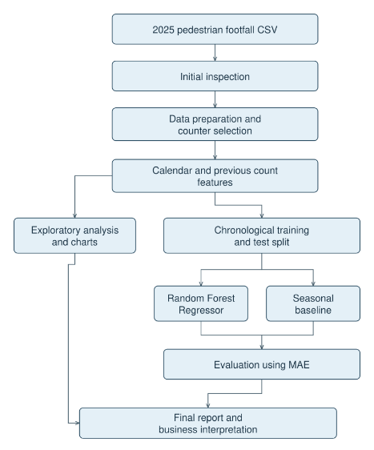
Figure 1. Proposed project workflow

7. Data Sources
In this project, we will use a Dublin City Council Pedestrian Footfall Dataset that is published on data.gov.ie. This contains 8,760 hourly data records from a network of counters across central Dublin, with timestamps and counts of pedestrians, suitable for pattern analysis and prediction modelling. The set is available under a Creative Commons license and will be used in conformity with that license, including acknowledgment of its source (Dublin City Council, n.d.).
8. Expected Deliverables
This project will end with a cleansed and described data set, a Jupyter notebook containing the analysis and a predictive model, and an evaluation of the model against a seasonal base line by mean absolute error (MAE). Clear visualizations will compare selected locations, illustrate observed foot traffic patterns and predict future numbers for peak and off-peak times. A final report will explain the findings, the errors and limitations of the models and discuss the possible use in the staffing, stock and promotions department and explain where caution is necessary.
9. Project Timeline
this project will have a development time of 2 semesters. In the first semester, from October to February, I will work on defining the problem, locating data sources, checking data quality and doing an initial data exploration, once the first semester is over, we will start the second one, in which I will be in charge of building the forecast model, comparing it with the seasonal baseline, creating the final visualizations, and interpreting the results for business use. The work will be updated step by step throughout the project. The report and deliverables will be completed before the second semester’s deadline
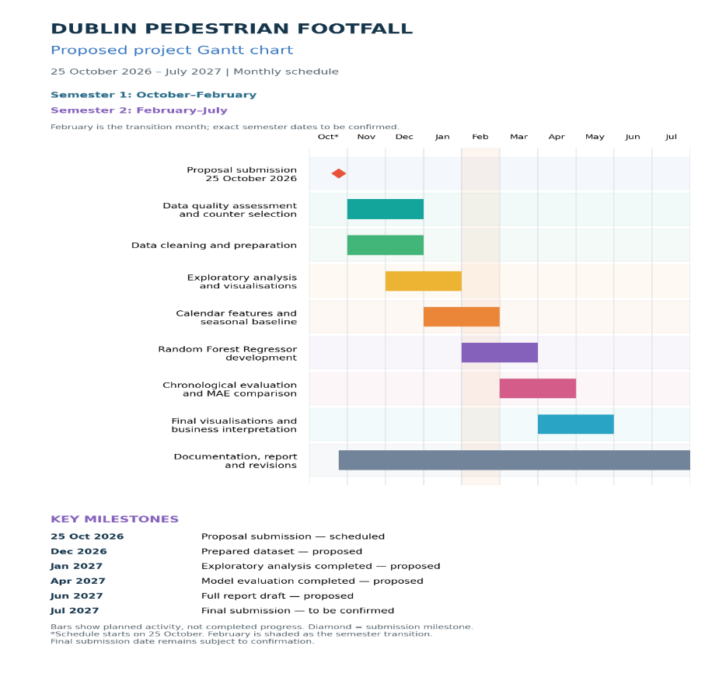
Figure 2. Project Gantt chart

10. Ethical and Legal Considerations
The work is based on collecting information about the number of people. In turn, this data is public and does not identify or recognise any individual person. The sources used for gathering information will be shared. The figures will be provided as estimates, not as absolute data. The movement of people will not be taken as proof of an improvement in business buying and selling. The data will be handled accurately, so that the values and missing figures at the time of comparison are not misleading. The use of AI will be declared and recorded
Use of AI Tools
I acknowledge the use of ChatGPT to help draft, shorten and revise parts of my project proposal, discuss dataset suitability, and create and format the architecture diagram and Gantt chart. The appendix includes prompts, relevant outputs and my evaluation of this assistance. I remain responsible for understanding, checking and deciding what to include in the final submission.
Declaration
By submitting this assessment, I confirm that I have read the CCT policy on academic misconduct and understand the implications of submitting work that is not my own or does not appropriately reference material taken from a third party or other source.
I declare it to be my own work and that all material from third parties has been appropriately referenced.
I further confirm that this work has not previously been submitted for assessment by myself or someone else in CCT College Dublin or any other higher education institution.

Delegation
I chose ChatGPT to improve the clarity of my proposal and to assist in organizing my work. I used Chat GPT to formulate, shorten, and revise the proposal text, discuss the suitability of the dataset, and create and format the architecture diagram and the Gantt chart. I compared suggestions and maintained responsibility for the project decisions and the content of my own proposal.
Description
I asked GPT for help with getting my proposal under the one-thousand-word limit and whether I should use a data set of 8,760 rows and 118 columns. In addition, I asked for an example of a Gantt chart, instructions for creating diagram boxes in a Google doc, and help with the graphical architecture. In response to GPT's prompts, I also requested a monthly Gant chart with month labels.

Discernment
I accepted the guidance and help that Chat GPT give me to keep within the thousand-word limit. I accepted amendments to the scope of the project which made it more definite, examined the architecture diagram to make sure it conformed to the intended phases of development, and asked for a redrawn version to improve the presentation. I changed the Gantt chart to show the expected months and semesters, realizing that some dates could not be confirmed without further notice. I classified the evaluation of the data set as an initial recommendation, because its suitability depends on data quality, not only on the 8,760 rows and 118 columns.

Diligence
For help with text editing, I acknowledge ChatGPT, which helped me review the data set, review the scope and create and format a system architecture diagram and Gantt chart. I have provided a log of relevant inputs, outputs and screens in the appendix. Before submitting, I shall check the word count, references, diagram stages and chronology. I shall make a distinction between the conclusions reached by the AI and those arrived at by me. Respect the data license and refrain from revealing anything further confidential or personal. I will take full responsibility for understanding and verifying the content.
References
Dublin City Council (n.d.) 2025 Pedestrian Footfall DCC. Available at: https://data.gov.ie/en\_GB/dataset/dublin-city-centre-footfall-counters/resource/ca145381-cedf-475a-9b96-6e43b76c8a98 (Accessed: 14 October 2026)
scikit-learn developers (n.d.-a) mean_absolute_error. Available at: https://scikit-learn.org/stable/modules/generated/sklearn.metrics.mean\_absolute\_error.html (Accessed: 21 October 2026).
scikit-learn developers (n.d.-b) RandomForestRegressor. Available at: https://scikit-learn.org/stable/modules/generated/sklearn.ensemble.RandomForestRegressor.html (Accessed: 21 October 2026).
scikit-learn developers (n.d.-c) TimeSeriesSplit. Available at: https://scikit-learn.org/stable/modules/generated/sklearn.model\_selection.TimeSeriesSplit.html(Accessed: 21 October 2026).

Appendix: AI prompts and outputs
A1
AI Tool: ChatGPT
Date: 14 October 2026
Purpose: To understand how to create a Gantt chart for the project timeline.
Exact prompt:
could you show me some Gantt chart examples so I can lear how to make one ?
My evaluation and use:
The images helped me understand how to make a Gantt chart, understand the duration of the activities, the tasks and how they are spread over a specific period of time.
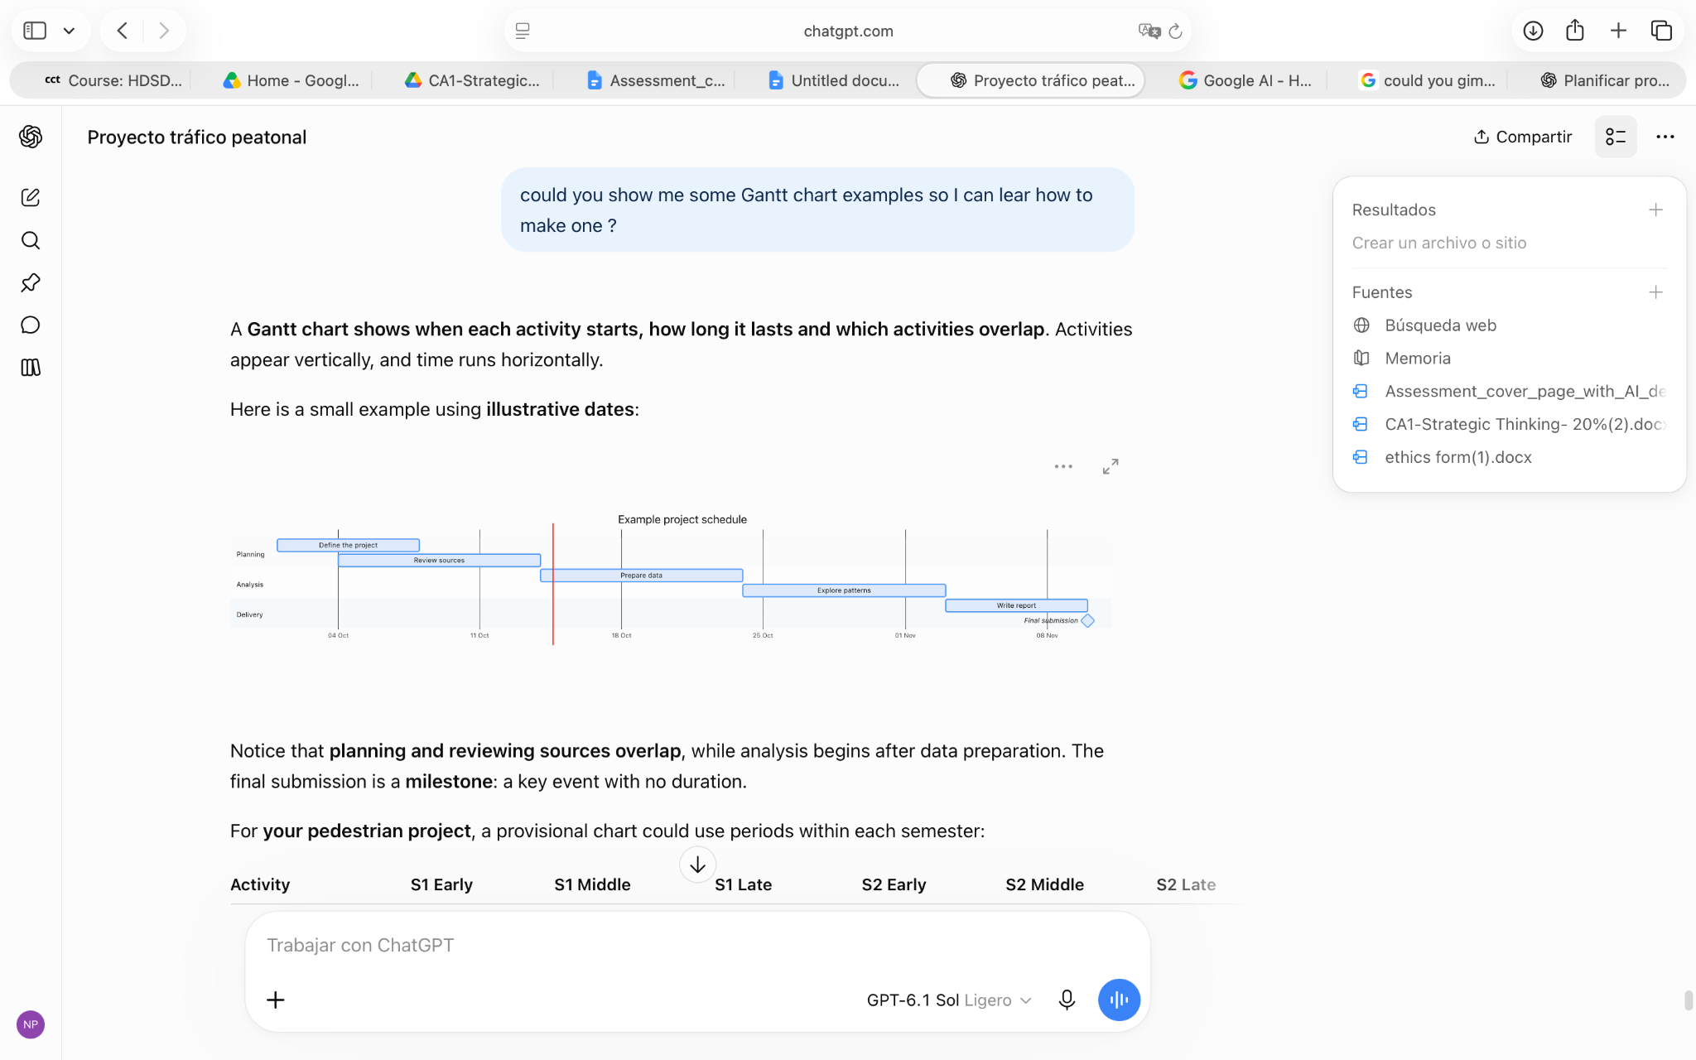

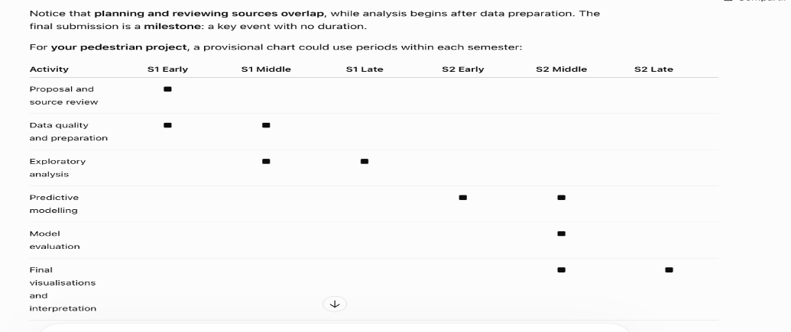

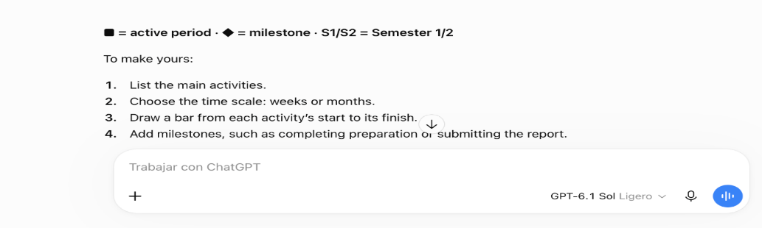

A2
AI tool: ChatGPT
Date: 14 October 2026
Purpose To assess whether the dataset is suitable for a project spanning two semesters.
Exact prompt:
I've checked the rows and columns (8760, 118) in the data I shared. do you think it's a good dataset for a one year project?
My evaluation and use:
The explanation helped me realize which points I need to pay attention to in order to get a quality job (data quality, manageable scope and predictive evaluation). In turn, he advised me that I could add previous years in the future to compare data. and at the same time it confirmed that my project is good for a year of work.
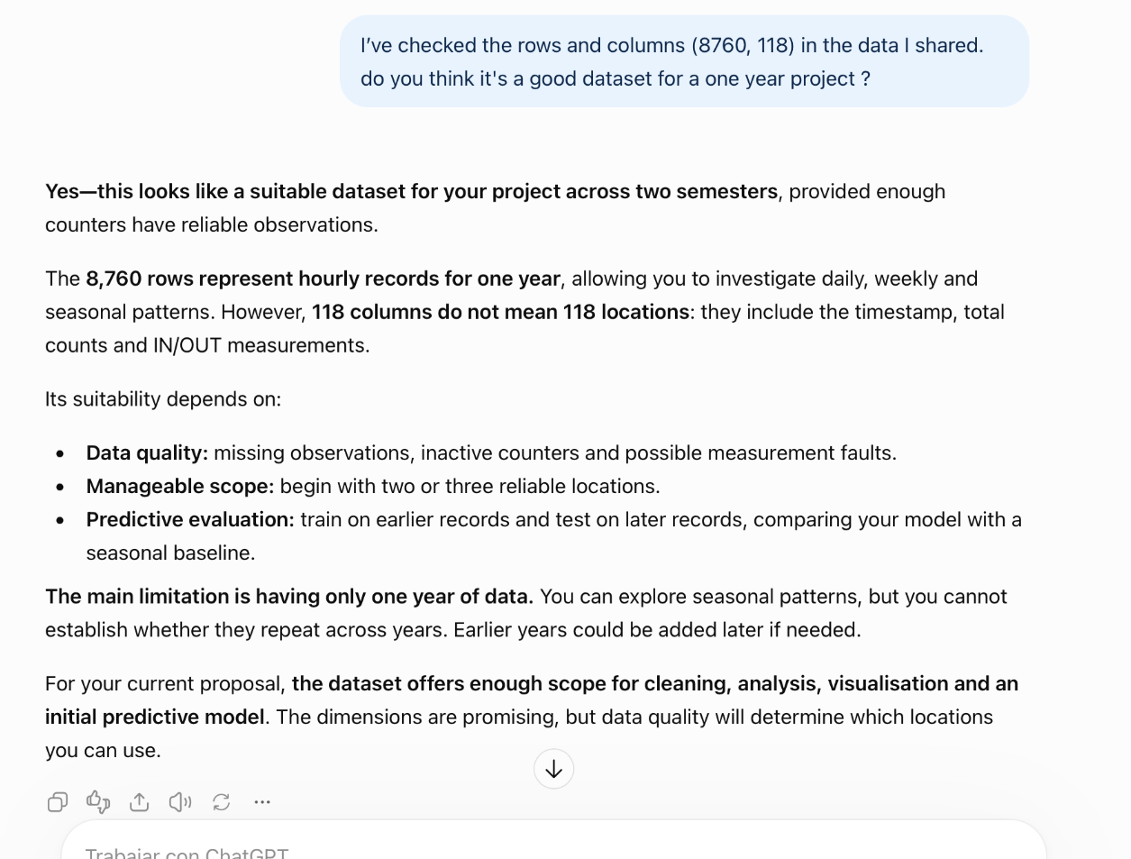

A3
AI tool: ChatGPT
Date: 18 October 2026.
Purpose: To learn how to create boxes and connectors for the project architecture diagram in Google Docs.
Exact prompt: I am making the architecture diagram for my project, but I don't know how to create the boxes to generate the diagram. I am working from google drive
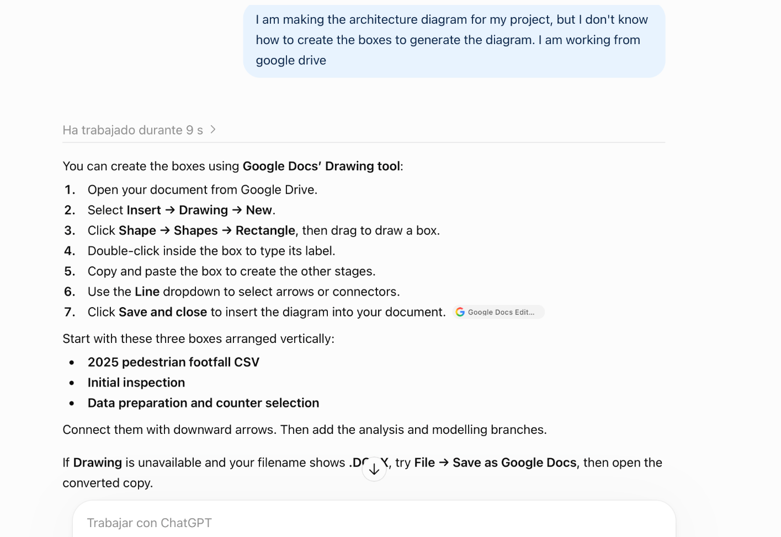
Relevant AI output:

My evaluation and use:
The instructions ChatGPT gave me to create the boxes and connectors in Google Drive were really helpful. But I had trouble fitting the diagram onto a word page, so I asked it to make one in imagen format. I checked that the revised diagram kept the stages and connections of my project

A4
AI tool: ChatGPT
Date: 20 October 2026
Purpose: To improve the layout of my architecture diagram while keeping the project stages
Exact prompt:
I will send you my architecture diagram for you to modify only its format while maintaining my project's stages. Send it to me as an image since mine has issues fitting into Word because it's too big.

Input:
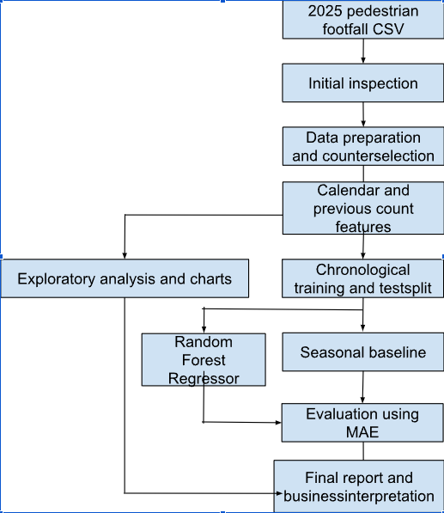
Relevant AI output:
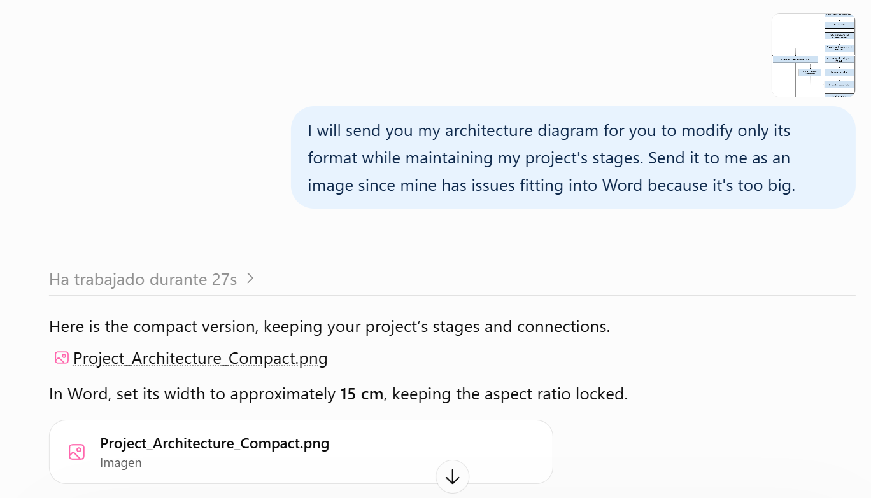
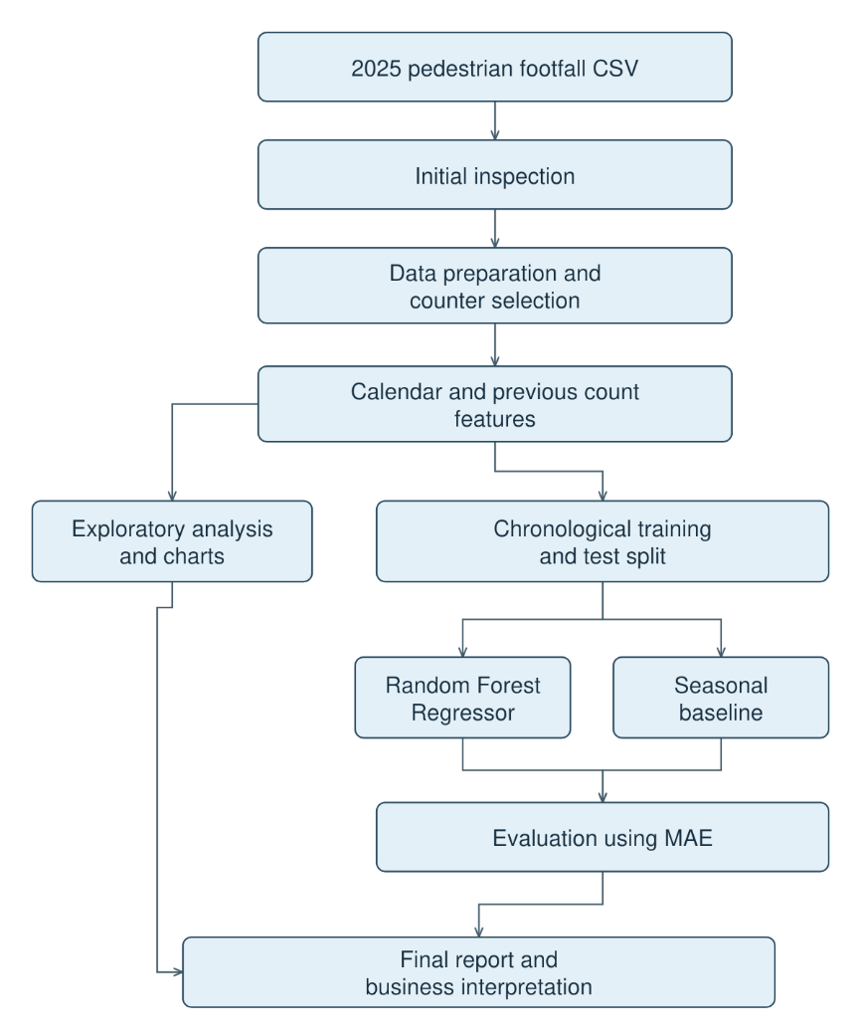
My evaluation and use:
After reviewing the design in image format that AI sent me, I realized that it was much easier to adjust the architecture diagram to my word page, since the one I made following ChatGPT’s instructions was more complicated to fit on the page
A5
AI tool: ChatGPT
Date: 20 October 2026
Purpose: To create a proposed monthly project schedule based on the proposal sections.
Exact prompt:
Could you create a vertical Gantt chart using my paragraphs for Aim and Objectives, Scope, Methodology, and Expected Deliverables, distributed from October 25, 2026, to July 2027, to show my full progress? Please provide it in an image format
Relevant AI output:
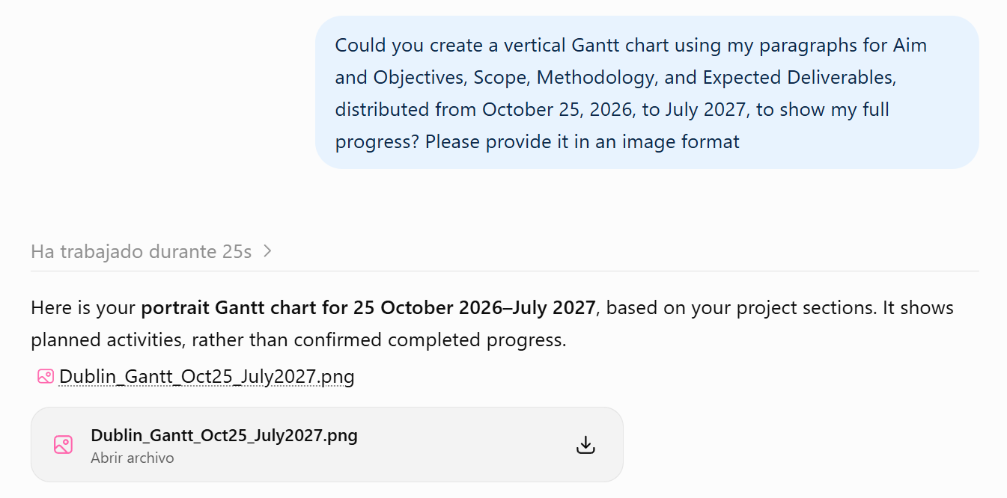
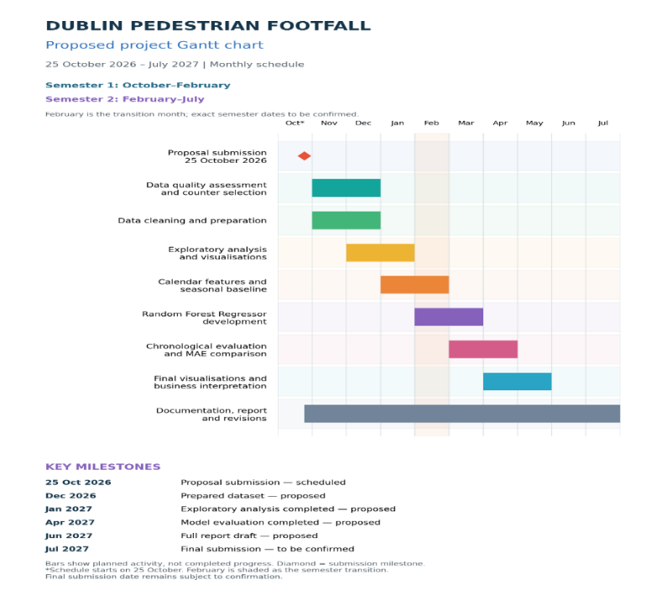
My evaluation and use:
I reviewed the proposed chart against the activities in my proposal. It helped organise the work into monthly phases and identify milestones. I understand that the bars represent planned activities rather than completed progress, and that the final deadline and semester boundaries still require confirmation.
A6
AI tool: ChatGPT
Date: 22 October 2026
Purpose: To review the proposal's length and improve wording while preserving my main ideas.
Exact prompt:
Please keep the paragraphs concise while preserving my main ideas, so that the complete proposal stays close to 1,000 words
Input:
The attached proposal, CA1- Strategic thinking (1).docx.
My evaluation and use:
I read the suggestions and kept my paragraphs unchanged since my project is within the world limit given by the teacher. I took into account the recommendations that ChatGPT gave me to make the necessary adjustments and modifications without changing the structures of my architecture diagram and my Gantt chart.

